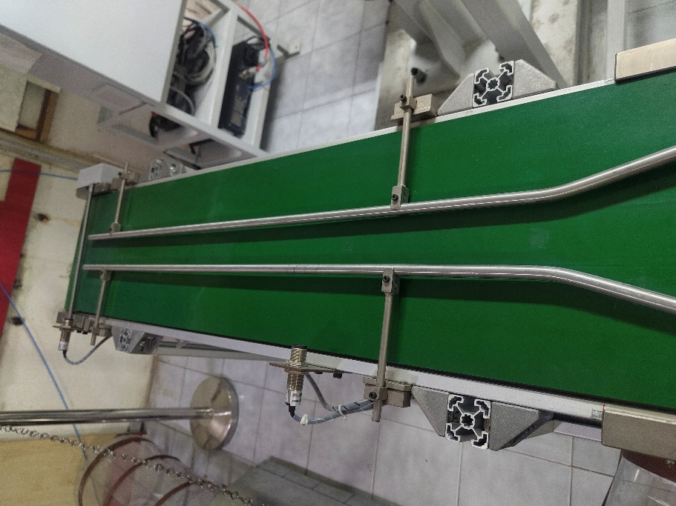
Figure 1: Conveyor system with adjustable guide rails and photoelectric sensors for position mapping and trigger synchronization.
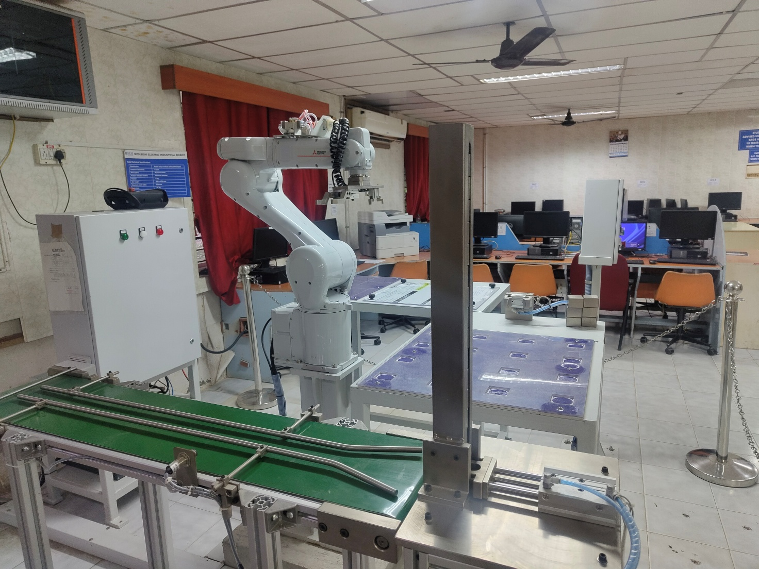
Figure 1: Lab setup with Mitsubishi RV-8CRL-D robot, encoder-based conveyor tracking system, and CR800-D controller.
Expt No:  05 | DETERMINISTIC CALIBRATION AND ENCODER SYNCHRONIZATION
Date:
05 / 03 /2026

- AIM:
To perform high-precision coordinate calibration between a linear transport system and a 6-axis robotic manipulator by mathematically mapping rotational encoder pulses to linear spatial displacement (P_EncDlt) on the Mitsubishi RV-8CRL-D industrial system.

- APPARATUS REQUIRED:
  - Manipulator System: Mitsubishi RV-8CRL-D 6-axis industrial robot.
  - Control Hardware: CR800-D series dedicated robot controller.
  - Software Suite: RT ToolBox3 integrated engineering environment.
  - End-of-Arm Tooling : Precision drawing effector configured within the tool coordinate system.
  - Infrastructure: Solid installation platform and standard TCP/IP or standard USB communication interface.

- THEORY:
Trajectory generation for planar symbolic mapping requires the mathematical decomposition of characters into primitive geometric segments.
- Core Principle:
For an industrial robot to accurately interact with moving objects on a conveyor (Dynamic Conveyor Tracking), the controller must mathematically correlate the physical displacement of the conveyor belt with the Cartesian coordinate system of the manipulator. This requires establishing a precise pulse-to-millimeter ratio.
- Working Mechanism:
  - Pulse Accumulation: As the conveyor moves, a connected rotary encoder generates digital pulses. The controller continuously reads this accumulated value via the M_ENC system variable.
  - Spatial Reference Mapping: By physically aligning the robot with a target on the conveyor at two distinct locations (upstream and downstream) and recording both the absolute robot coordinates (P_CURR) and the encoder pulse counts at those exact moments, a mathematical slope vector is derived.
  - Overflow Correction: Incremental encoders have a maximum logical threshold before the pulse count resets or rolls over. The algorithm must account for boundary crossings (e.g., the $\pm80,000,000$ pulse threshold) to maintain tracking integrity.
- Key Formula:
The linear spatial displacement per single encoder pulse (P_EncDlt) across any axis is calculated as:
$$P_{EncDlt}= \frac{P_{2}-P_{1}}{EncDiff}$$

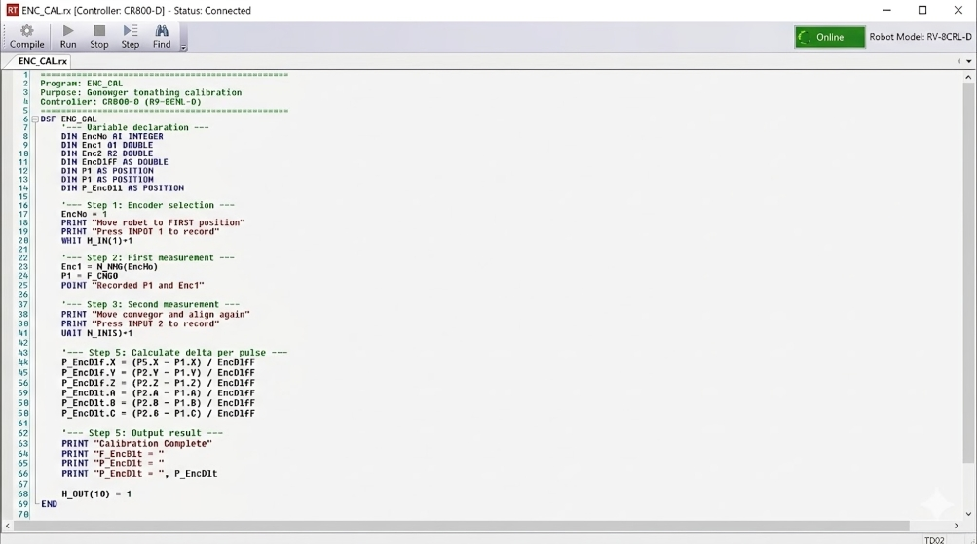
Figure : RT ToolBox3 Source Code for Conveyor Tracking Calibration.

- PROCEDURE:
- Setup & Connections:
Interface the conveyor's rotary encoder signal to the CR800-D controller's tracking card. Ensure the external trigger inputs (Input 1 and Input 2) are mapped to the teaching pendant or physical pushbuttons to capture the measurement snapshots.
- Algorithm & Logic:
  - Initialize variables and select the target encoder channel (EncNo = 1).
  - First Measurement: Jog the robot to a physical reference point on the upstream section of the conveyor. Trigger Input 1 to record the current position (P1) and pulse count (Enc1).
  - Second Measurement: Run the conveyor to move the reference point downstream. Jog the robot to perfectly realign with the reference point. Trigger Input 2 to record the new position (P2) and pulse count (Enc2).
  - Delta Calculation: Calculate the raw pulse difference (EncDiff) and apply the necessary overflow/underflow correction logic.
  - Compute the coordinate delta (P_EncDlt) for all 6 degrees of freedom (X, Y, Z, A, B, C).
- Execution Steps:
  - Execute the ENC_CAL program in manual/step mode.
  - Follow the generated PRINT prompts on the teaching pendant to align the robot TCP with the physical target and trigger the respective inputs.
  - Verify the final calculated P_EncDlt matrix outputted on the pendant screen.
- Observation Instructions:
Analyze the resulting coordinate delta values. Assuming the conveyor moves strictly along one primary Cartesian axis (e.g., the robot's Y-axis), the calculated delta for that specific axis should be a distinct non-zero value representing the millimeter-per-pulse ratio, while the remaining orthogonal axes (X, Z) and rotational postures (A, B, C) should theoretically calculate to zero.

- RESULT AND OBSERVATION:
The system successfully derived the pulse-to-metric conversion factor $P_{EncDlt}$. The deterministic relationship established during calibration ensures that subsequent conveyor tracking operations maintain high spatial accuracy, as verified by functional evaluations.

